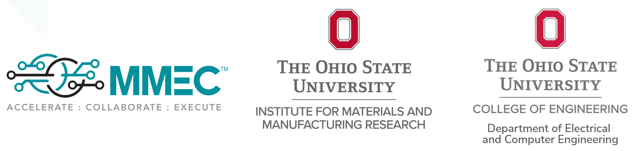

Dear Prospective MIST Student Applicant,
The Midwest Infrared Semiconductor Technology (MIST) Workshop at The Ohio State University brings together students, researchers, and industry leaders working across the electro-optical and infrared (EO/IR) semiconductor ecosystem. To help you explore this field and better understand the technical landscape prior to applying, we have compiled the following short set of introductory resources. These materials provide a high-level overview of EO/IR systems, their applications, and the research and development challenges that shape the field today. Reviewing them is not required for application, but it will help you become familiar with the concepts, terminology, and innovation pipeline that the MIST workshop is designed to highlight.
Best Regards,
MIST Planning Committee Members

Introduction to EO/IR (Electro-Optical / Infrared Systems)
Electro-Optical / Infrared (EO/IR) systems combine “electro‑optical” (visible and near‑infrared light) sensors with thermal infrared (IR) sensors to provide imaging and detection capabilities across both the light and heat spectra. In essence, the EO portion acts like a camera that captures what is visible (or nearly visible) to the eye (or in the near‑IR), while the IR portion senses the heat (thermal radiation) emitted by objects. The fusion of these two enables monitoring, tracking, and identification of objects under a wide range of lighting and weather conditions (including night or obscured visibility) that a conventional optical camera alone could not handle. (https://www.flir.com/discover/rd-science/what-is-eoir/)
EO/IR systems are widely used in defense, aerospace, surveillance, and unmanned aerial systems (UAS). For example, EO/IR payloads on drones or aircraft allow operators to “see” both visual detail and heat signatures, helping in tasks like search & rescue, object detection, or targeting. (https://www.flyeye.io/drone-acronym-eo-ir/). But designing EO/IR systems involves challenges: the atmosphere can attenuate or distort signals (especially in infrared), sensors must often balance size, weight, and power (SWaP), and processing or fusing data in real time is computationally demanding. (https://www.ansys.com/blog/ansys-solution-overview-electro-optic). These are the six different steps in the research and development of infrared focal plane arrays.
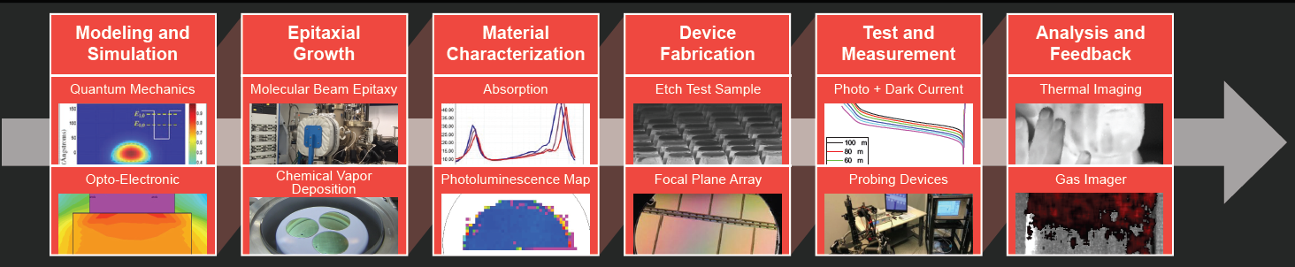

Recommended Resources
- Nice overview of infrared by NASA https://science.nasa.gov/ems/07_infraredwaves/
- What is Imaging System Design and Analysis? (YouTube)
https://www.youtube.com/watch?v=ls_H5neDNBc
- Current Electro‑Optical Infrared Sensors Overview (YouTube)
https://www.youtube.com/watch?v=-PAO0M74hWY
- How might vision goggles work (YouTube)
https://youtu.be/UAeJHAFjwPM
- A Tutorial on Electro‑Optical/Infrared (EO/IR) Theory and Systems (IDA)
https://www.ida.org/-/media/feature/publications/a/at/a-tutorial-on-e-lectro--opticalinfrared-eoir-theory-and-systems/ida-document-d-4642.ashx
- What Is EO?/IR? (Teledyne FLIR)
https://www.flir.com/discover/rd-science/what-is-eoir/
- A little more technical depth
https://www.opto-e.com/en/basics/ir-optics
The Midwest Microelectronics Consortium (MMEC) is a public–private, nonprofit organization that convenes industry, academia, and government partners in the U.S. Midwest to drive innovation in microelectronics. For undergraduate students, MMEC offers opportunities to engage with cutting-edge research, access shared facilities, and collaborate across sectors. It helps bridge the “lab-to-fab” gap, enabling student projects to move from proof-of-concept to prototyping within a real ecosystem.
Additionally, because MMEC is part of the national Microelectronics Commons network, involvement can connect students to a broader community and funding resources.

